- Newsletter  Quarter 1 2019  What’s Inside  1-Meeting Information  2-Speaker Bios  3-Professional Growth  4-Chapter Leadership  5-Employment Opportunities | Monthly Meetings  Meetings are held the 3rd Tuesday of every month at Sizzler located at 1010 Postal Way in Springfield, Oregon  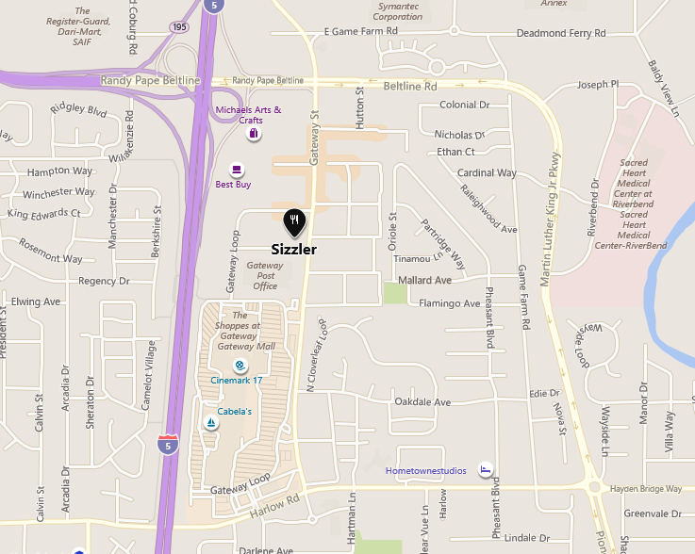  Chapter meetings are held the 3rd Tuesday of each month (September – June) at the Sizzler Restaurant located at 1010 Postal Way (off Gateway Blvd) in Springfield Oregon. The Cascade Chapter does not hold meetings in July and August each year.  Come at 11:30 a.m. to order your lunch. Formal presentations and Chapter business starts at 12 noon. You do not need to be a member to attend!
- Chapter Info  Name  Cascade Chapter ASSP  Oregon Counties Served  Lincoln, Benton, Linn, Lane, Coos, Douglas  Website  https://cascade.assp.org/ | February 19th Speaker  Kristina Deschaine, Deputy State Fire Marshal in Lane County since 2001 will be at our meeting. She will discuss some items that are looked at during a fire inspection and go over portions that need explanations.  March 19th Speaker  “Common Industrial Hygiene Concerns” will be the March topic. It will be presented by Averie Foster of OR-OSHA.  April 16th/May 21st Speaker  None scheduled thus far. If you would to speak or know somebody would add value to our Association, please contact Kristi Hayden at KHayden@eugene-or.gov  June 18th Speaker  Oregon State University/Master in Public Health Student Intern Project presentation.  Professional Growth  Oregon GOSH Conference  March 4th-7th 2019  Oregon Convention Center-Portland, Or.  www.oregongosh.com  Link provides access to registration, schedule, and session information.  Long drives? Listen to a podcast…  Safety Standards and Tech Podcasts:  https://www.assp.org/standards/safety-standards-and-tech-pubs-podcast  Challenge conventional thinking: https://preaccidentpodcast.podbean.com/  OSHA Outreach Continuing Ed Programs  https://osha.washington.edu/osha/calendar  Click the link above to discover top quality outreach programs to further professional development. Become an OSHA Outreach trainer for general and industry and construction. Brush up of OSHA recordkeeping, ergonomics, and more!  Chapter Leadership  President-Kay Coots  Vice President-Lance Hughes  Second Vice President-Dennis Hughes  Secretary-Twyla Gallaway  Treasurer-Dave Lindelien  Webpage-Brandon Mattox  Governmental Affairs-Brent Pockrus  Program Co-Chairs-Kristi Hayden and Jason Wallace  House Delegate-Kristi Hayden  Newsletter- Evan Church  We will be announcing candidates for next year’s officer positions. ASSP Cascade is also planning for its 2020 Conference and is looking for volunteers to assist!  Posted Job Opportunities  Found on Indeed:  Safety & Compliance Associate (bilingual)  Leavitt’s Freight Service  Eugene, Or  Safety Supervisor  Job-Site Safety, Ltd  Eugene, Or  Environmental, Safety, and Health Coordinator  Fall Creek Farm & Nursery, Inc.  Lowell, Or  Process Safety Engineer/Leader  W.R. Grace & Co.  Albany, Or  Building Safety Inspector I or II  City of Corvallis  Corvallis, Or  HR Specialist/Health and Safety  Work Unlimited  Corvallis, Or  Safety Professional  Roseburg Forest Products  Dillard, Or  If you have or know of a potential job opportunity in the safety and health profession, let us know!

