[](https://cascade.assp.org/)

April

2019

Meeting Info:

Meetings are held the 3rd Tuesday of every month at Sizzler located at 1010 Postal Way (off Gateway Blvd) in Springfield, Or. The Cascade Chapter does not hold meetings in July and August each year.

The no host lunch begins at 1130. Formal presentations and chapter business starts at 1200 noon.

You do not need to be a member to attend!

The following individuals have been nominated by this year’s nomination committee for the elected positions with the Cascade Chapter of American Society of Safety Professionals:

President: Lance Hughes

Vice President: Dennis Hughes

Secretary: Twyla Gallaway

Treasurer: David Lindelien

House Delegate: Kristi Hayden

Delegate at Large: Mel Smith

Chapter Members may submit a signed petition nominating additional individuals for an elected office. A valid petition requires the signatures of 5 members. The petition must include, by written acceptance of the nominees(s) and shall be submitted to the Chairperson of the Nominations & Elections Committee (Kay Coots) no later than April 21st, 2019.

Officer Elections

Exploring open source software opportunities.

this issue

Officer Elections **P.1**

Professional Development **P.2**

Job Announcements **P.3**

Chapter Information **P.4**

[](https://cascade.assp.org/)

April 16th Speaker

“Stop the Bleed” Campaign. Join Eugene/Springfield Fire staff Nathan Kunasek and his team from Fire Station #8. Its is an effort to teach bleeding control techniques to make a difference in a life threatening emergency event.

May Speaker-TBD

June 18th Speaker

Oregon State Unveristiy/Master in Public Health Intern Project presentation.

March 19th Recap

Averie Foster of Oregon-OSHA spoke to the group about common industrial hygiene concerns. She works in the consultation side of OR-OSHA in the health division. Their role is to provide free and confidential industrial hygiene services such as noise monitoring and air sampling. This service is invaluable to Oregon business as it can provide the information necessary to determine whether or not your employees are protected. The service can also assist with regulatory requirements. Both of these aspects will keep cost down and increase the health of your business.

Upcoming 2019 Safety and Health Conferences in Oregon

May 14-16 Portland: Northwest Safety and Health Summit by Region X VPPPA

June 3-4 Pendleton: Blue Mountain Occupational Safety and Health Conference

September 16-17 Bend: Central Oregon Occupational Safety and Health Conference

October 15-17 Ashland: Southern Oregon Occupational Safety and Health Conference

December 3-6 Portland: Western Pulp, Paper, and Forest Products Safety and Health Conference

Cascade Occupational Safety & Health Conference

The Chapter is planning for next year’s March conference in Eugene and is looking for volunteers to assist.

OSHA Outreach Continuing Education Programs

<https://osha.washington.edu/osha/calendar>

Click the link above to discover top quality outreach programs to further professional development. Become an OSHA Outreach trainier for general industry and construction. Brush up on OSHA recordkeeping, ergonomics, and more!

Professional Development

Exploring open source software opportunities.

April

2019

Chapter Info:

Name

Cascade Chapter ASSP

Oregon Counties Served:

Lincoln, Benton, Linn, Lane, Coos, and Douglas

Website:

<https://cascade.assp.org>

[](https://cascade.assp.org/)

Total Worker Health HoC

ESH (Environmental, Safety, and Health) Coordinator

Fall Creek Farm & Nursery

Lowell, Oregon

Environmental Health and Safety Manager

Northern Gold Foods, Ltd.

Junction City, Oregon

Safety Manager

Greenberry Industrial

Eugene, Oregon

Health and Safety-CPR and First Aid Instructor

American Red Cross

Eugene, Oregon

Safety Technician

Selmet, Inc

Albany, Oregon

Safety Coordinator

Pacific Seafood

Newport, Or

Safety Professional

Roseburg Forest Products

Coquille, Oregon

Job Announcements (pulled from Indeed)

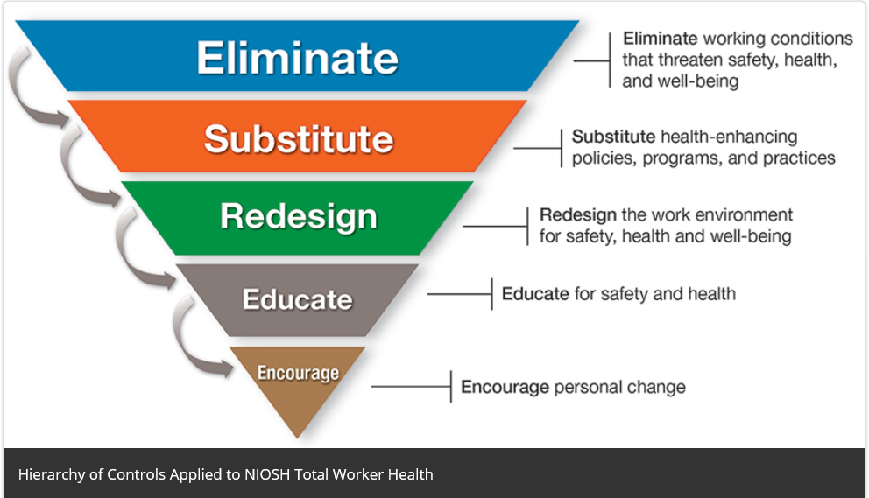

Total Worker Health

CDC-NIOSH has developed a Hierarchy of Controls for Total Worker Health. Check out the link.

<https://www.cdc.gov/niosh/twh/letsgetstarted.html>

Already have a Total Worker Health program? Share your program with ASSP and be included in next month’s newsletter!

April

2019

[](https://cascade.assp.org/)

Long drives? Listen to a podcast…

Safety Standards and Tech Podcasts:

<https://www.assp.org/standards/safety-standards-and-tech-pubs-podcast>

Challenge conventional thinking: <https://preaccidentpodcast.podbean.com/>

Chapter Leadership

President-Kay Coots

Vice President-Lance Hughes

Second Vice President-Dennis Hughes

Secretary-Twyla Gallaway

Treasurer-Dave Lindelien

Webpage-Brandon Mattox

Governmental Affairs-Brent Pockrus

Program Co-Chairs-Kristi Hayden and Jason Wallace

House Delegate-Kristi Hayden

Newsletter- Evan Church

April

2019